**Chat Dashboard Design Document**

**Overview**

The Chat Dashboard is a key component of the Airiam RAG Service, providing users with a conversational interface to interact with documents using Retrieval-Augmented Generation (RAG) capabilities. This dashboard allows users to create, manage, and participate in AI-assisted conversations that can reference specific documents for context-aware responses.

This document outlines the functionality, design elements, and implementation details for the Chat Dashboard. It's structured to provide developers with a clear understanding of the components, their interactions, and the expected user experience. Each UI element is described with its purpose, behavior, and technical implementation details.

The Chat Dashboard leverages the RAG capabilities of the system, allowing the AI to generate responses based on the content of specific documents. This creates a powerful tool for exploring, analyzing, and extracting insights from document collections.

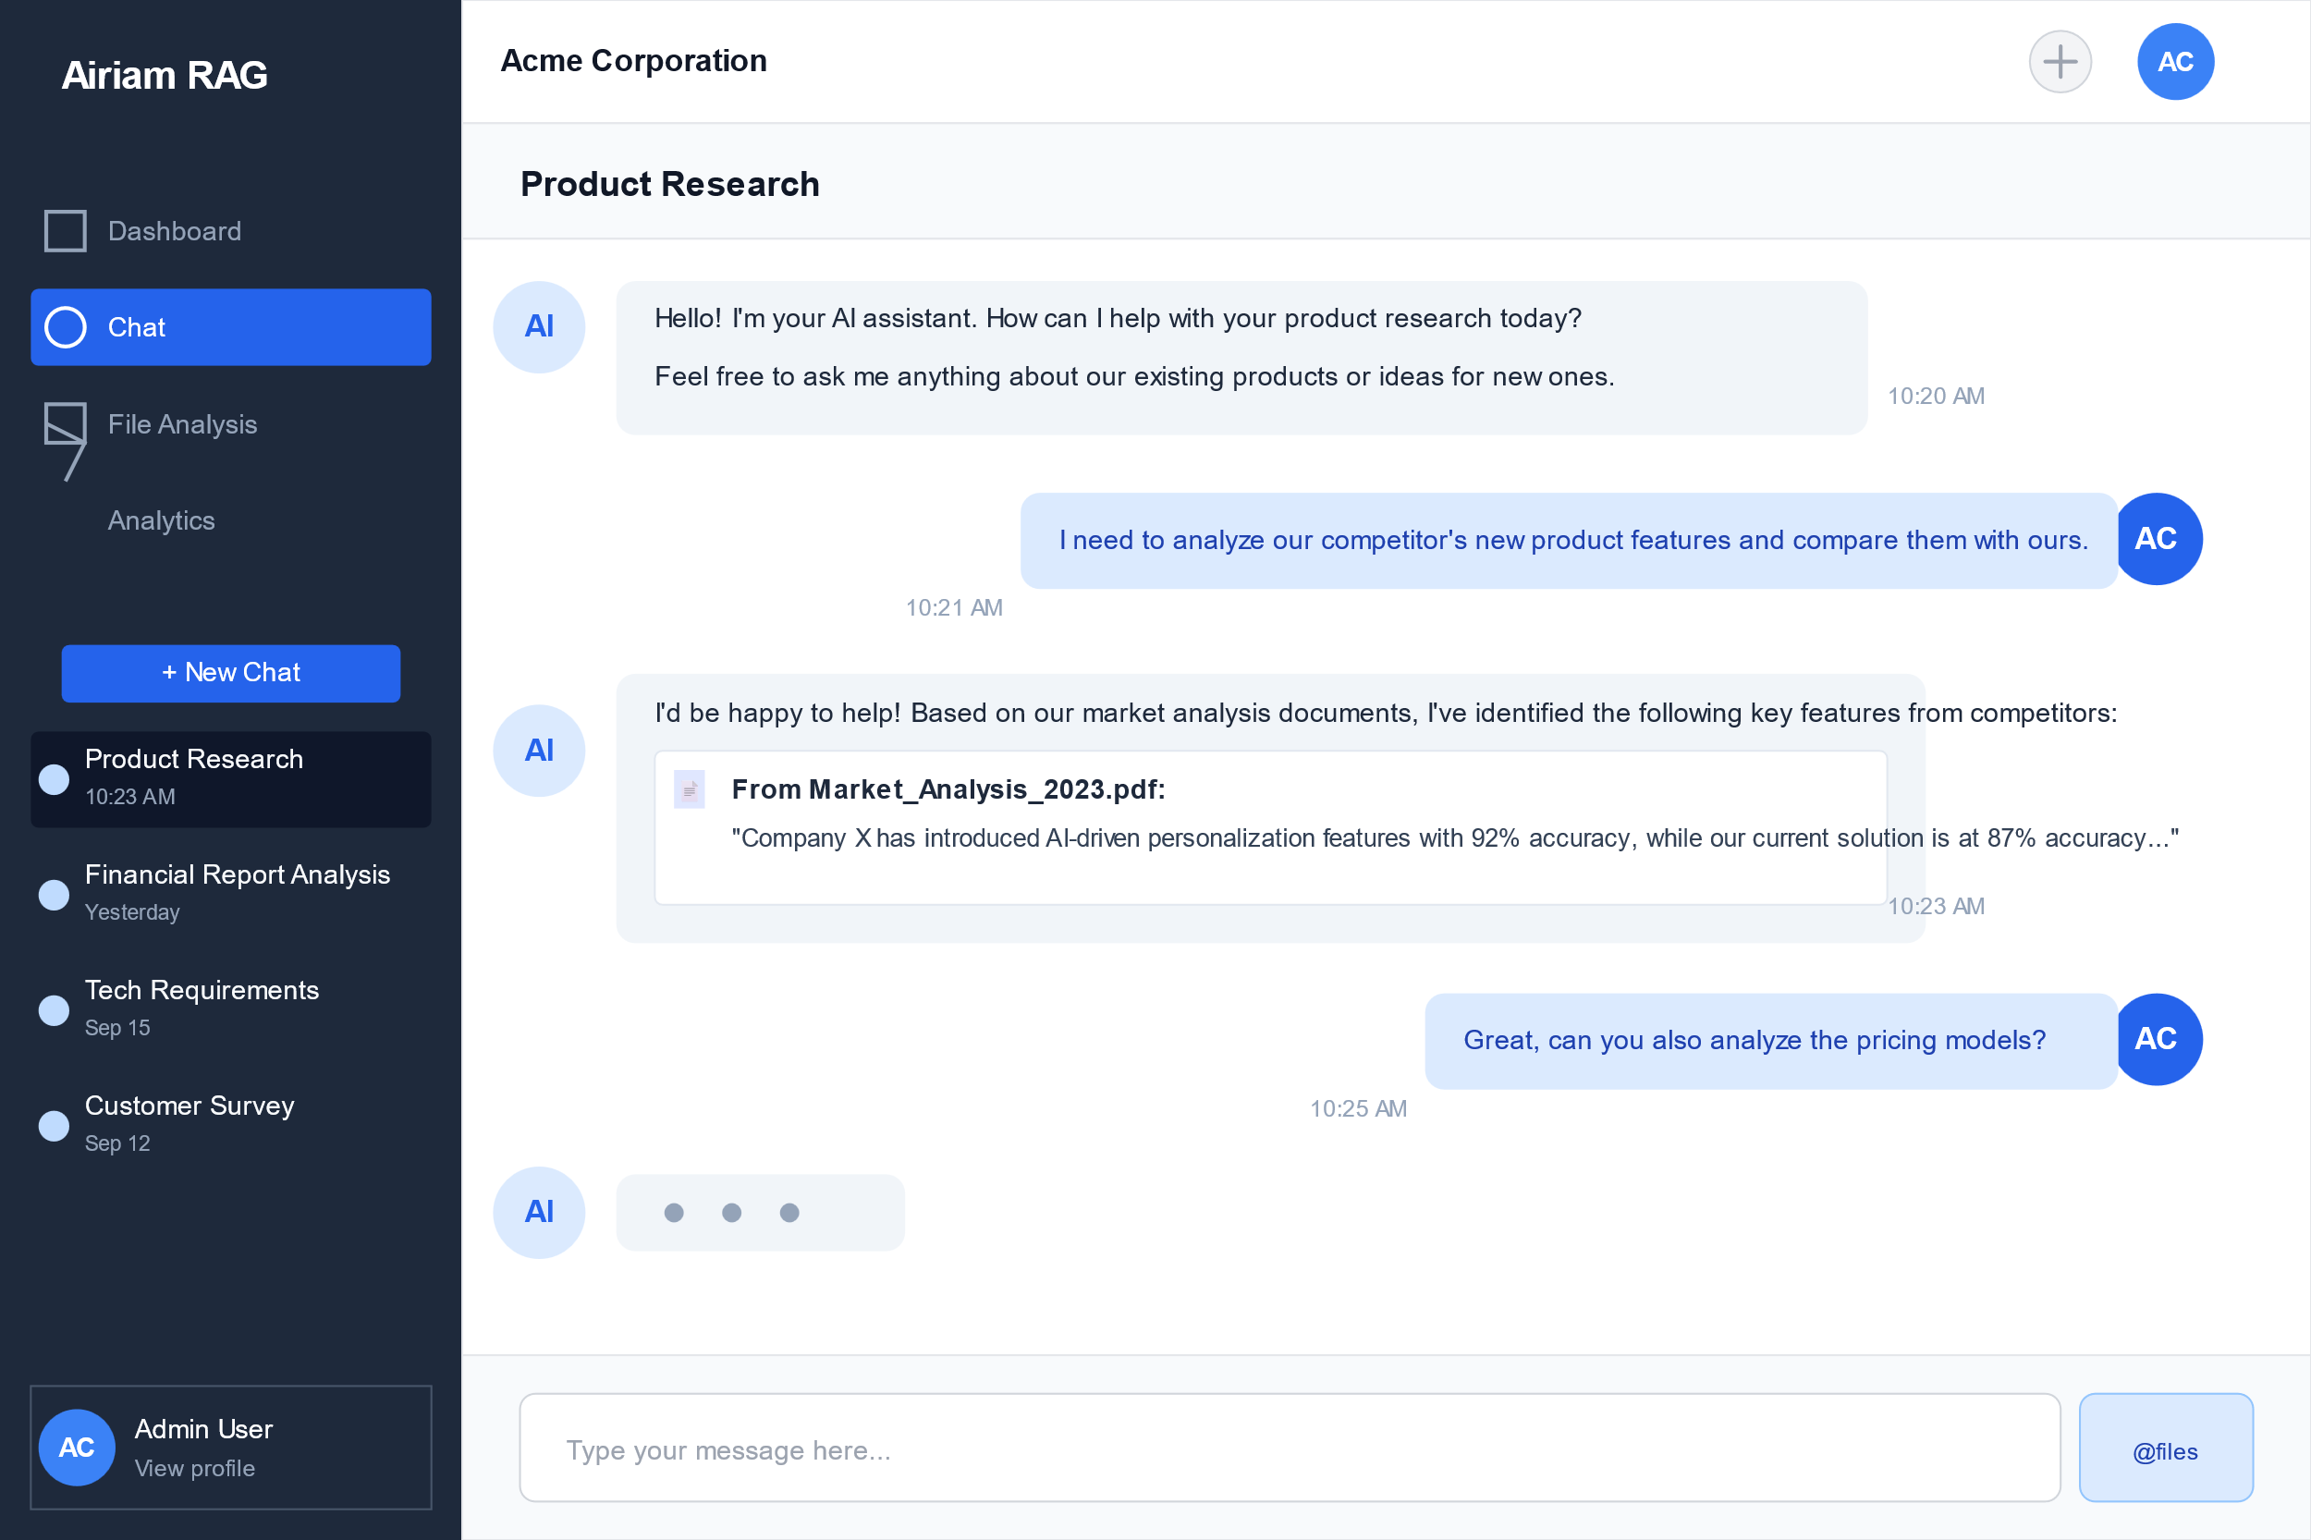

**Dashboard Components and Functionality**

**1. Chat List Page**

**Header Section**

* **Title**: Displays "Chat" in a prominent font (text-2xl, font-semibold)
* **New Chat Button**:
  + Located in the middle left side
  + Primary button with "New Chat" icon and "New Conversation" text
  + When clicked, opens the Create Conversation Modal
  + Triggers the createConversation action in the chat slice

**Conversation Grid**

* **Layout**: Responsive grid that displays 2 column on mobile, and 4 on large screens
* **Conversation Cards**:
  + Each card represents an existing conversation
  + Shows conversation title, snippet of the last message, message count, and timestamp
  + If the conversation has file context, it displays the file count with a document icon
  + Includes an ellipsis menu for conversation actions (currently only Delete)
  + Clicking on a card navigates to the individual conversation page
  + Card has hover effect (shadow-md)

**Empty State**

* **Displayed when**: No conversations exist
* **Content**:
  + Chat bubble icon
  + "No conversations yet" title
  + "Start a new conversation to chat with your AI assistant" description
  + "New Conversation" button that opens the Create Conversation Modal

**2. Create Conversation Modal**

**Modal Header**

* **Title**: "Create New Conversation" or "Select Files" depending on the current view
* **Close Button**: "X" icon in the top-right that closes the modal

**Conversation Creation Form**

* **Title Input**:
  + Label: "Conversation Title"
  + Default value: "New Conversation"
  + Required field that must not be empty
  + Full width input
* **Context Files Section**:
  + Label: "Context Files"
  + "Select Files" button to switch to file selection view
  + Display area showing selected files (empty by default)
  + Each selected file has a document icon, name, and remove button
* **Action Buttons**:
  + "Cancel" button (secondary style) - closes the modal without creating a conversation
  + "Create" button (primary style) - creates the conversation and navigates to it
  + Create button should be disabled when the title is empty
  + Shows loading state during API calls

**File Selection View**

* **File List**:
  + Grid of file cards showing only indexed files
  + Each card has a checkbox for selection
  + Shows file icon, name, size, and last modified date
  + Selected files have highlighted styling with a checkmark
  + Empty state when no indexed files exist
* **Search Input**:
  + Allows filtering files by name
  + Updates the list in real-time as the user types
* **Action Buttons**:
  + "Back" button to return to the conversation form
  + "Done" button to confirm file selection and return to the form
  + Shows selected file count

**3. Individual Conversation Page**

**Header Section**

* **Back Button**: Arrow icon that navigates back to the chat list
* **Conversation Title**: Displays the title of the current conversation
* **File Context Indicator**:
  + Shows number of files in context (e.g., "2 files in context")
  + Only visible when files are selected
  + Includes document icon
* **Change/Add Files Button**:
  + Shows "Change Files" when files exist in context, "Add Files" otherwise
  + Opens the File Context Selector modal
* **Options Menu**:
  + Ellipsis icon that opens a dropdown menu
  + Currently only contains "Delete conversation" option

**File Context Banner**

* **Displayed when**: The conversation has files in the context
* **Content**:
  + Information icon
  + "Context files:" label followed by the names of the files
  + Light blue background to visually distinguish it

**Message Thread**

* **Container**:
  + Card with white background
  + Fixed height (calc(100vh-320px)) with vertical scrolling
  + Automatically scrolls to bottom when new messages arrive
* **User Messages**:
  + Aligned to the right
  + Blue background with white text
  + Rounded corners
* **Assistant Messages**:
  + Aligned to the left
  + White background with AI icon
  + Can include source citations with collapsible details
  + Sources show file name, page number (if available), and the quoted text
  + Toggle to show/hide sources
* **Empty State**:
  + Shown when the conversation has no messages
  + Chat icon, title, and description
  + Encourages the user to ask a question

**Message Input**

* **Text Area**:
  + Placeholder: "Type your message..."
  + Auto-resizes based on content
  + Supports pressing Enter to send (Shift+Enter for new line)
  + Displays at the bottom of the page
  + Full width with right-aligned send button
* **Send Button**:
  + Paper airplane icon
  + Primary button style
  + Disabled when the input is empty or when a message is being sent
  + Shows loading state during API calls

**4. File Context Selector Modal**

**Modal Header**

* **Title**: "Select Files for Context"
* **Close Button**: "X" icon that closes the modal

**Search Input**

* **Functionality**: Filters files by name as the user types
* **Placeholder**: "Search files..."
* **Full width** with appropriate padding

**File List**

* **Content**:
  + Scrollable list of indexed files
  + Each file has a checkbox, icon, name, size, and date
  + Selected files have highlighted styling
  + Clicking anywhere on the row toggles selection
  + Empty state when no indexed files exist
* **Action Buttons**:
  + "Cancel" button (secondary style) - closes the modal without changing context
  + "Save" button (primary style) - applies the selected files as context
  + Shows selected file count (e.g., "Save (3 files)")

**Testing Procedures**

**1. Chat List Page Testing**

**Header Testing**

1. **Title Display Test**:
   * Verify that "Chat" is displayed in the header with the correct styling
2. **New Conversation Button Test**:
   * Click the "New Conversation" button
   * Verify that the Create Conversation Modal opens
   * Verify that the button has the correct icon and styling

**Conversation Grid Testing**

1. **Rendering Test**:
   * Create multiple conversations
   * Verify that all conversations appear in the grid
   * Verify that the most recent conversations appear first
2. **Responsive Layout Test**:
   * Resize the browser window to test different breakpoints
   * Verify the grid adapts correctly (1 column on mobile, 2 on medium, 3 on large)
3. **Card Content Test**:
   * Verify each card shows the correct conversation title
   * Verify the last message snippet is displayed correctly
   * Verify the message count and timestamp are accurate
   * For conversations with file context, verify the file count is displayed
4. **Navigation Test**:
   * Click on a conversation card
   * Verify navigation to the correct conversation page
5. **Delete Functionality Test**:
   * Click the ellipsis menu on a conversation card
   * Click "Delete conversation"
   * Verify the confirmation dialog appears
   * Confirm deletion and verify the conversation is removed from the list

**Empty State Testing**

1. **Display Test**:
   * Delete all conversations
   * Verify the empty state is displayed with the correct content
   * Click the "New Conversation" button
   * Verify the Create Conversation Modal opens

**2. Create Conversation Modal Testing**

**Modal Display Testing**

1. **Open/Close Test**:
   * Click "New Conversation" to open the modal
   * Click the X button to close it
   * Re-open and click outside the modal to verify it closes
   * Re-open and click Cancel to verify it closes
2. **Title Input Test**:
   * Verify the default value is "New Conversation"
   * Clear the input and verify the Create button is disabled
   * Enter a new title and verify it accepts input
3. **Context Files Display Test**:
   * Verify the context files section initially shows empty state
   * Select files (procedure below) and verify they appear in this section
   * Click the X on a file and verify it's removed from selection

**File Selection Testing**

1. **View Toggle Test**:
   * Click "Select Files" button
   * Verify the view changes to file selection
   * Click "Back" and verify it returns to the form view
2. **File List Test**:
   * Verify only indexed files are displayed
   * Verify file details (name, size, date) are correct
   * Select multiple files and verify visual selection state changes
   * Click "Done" and verify selected files appear in the form view
3. **Search Functionality Test**:
   * Enter text in the search input
   * Verify the file list filters correctly
   * Clear search and verify all files return

**Conversation Creation Test**

1. **Form Submission Test**:
   * Enter a title and select files
   * Click Create
   * Verify loading state is shown
   * Verify navigation to the new conversation page once created
   * Verify the new conversation appears in the chat list
2. **Error Handling Test**:
   * Simulate network error (disconnect internet)
   * Attempt to create a conversation
   * Verify appropriate error message is displayed

**3. Individual Conversation Page Testing**

**Header Testing**

1. **Navigation Test**:
   * Click the back button
   * Verify navigation returns to the chat list
2. **Title Display Test**:
   * Verify the conversation title is correctly displayed
3. **File Context Display Test**:
   * For a conversation with files in context, verify the file count is displayed
   * For a conversation without files, verify this element is not shown
4. **Change/Add Files Button Test**:
   * Click the button and verify the File Context Selector modal opens
   * Verify the button text changes appropriately based on context status
5. **Delete Functionality Test**:
   * Click the ellipsis menu
   * Click "Delete conversation"
   * Verify the confirmation dialog appears
   * Confirm deletion and verify navigation to the chat list

**Message Thread Testing**

1. **Message Display Test**:
   * Verify user messages are displayed on the right with correct styling
   * Verify assistant messages are displayed on the left with correct styling
   * Verify message content is rendered correctly including multi-line text
2. **Source Citation Test**:
   * For assistant messages with sources, verify sources are displayed
   * Click to collapse/expand sources and verify the toggle works
   * Verify source details (file name, page, snippet) are correct
3. **Empty State Test**:
   * Create a new conversation with no messages
   * Verify the empty state is displayed correctly
4. **Scrolling Test**:
   * Add many messages to exceed the visible area
   * Verify scrolling works correctly
   * Send a new message and verify automatic scroll to bottom

**Message Input Testing**

1. **Input Functionality Test**:
   * Type text and verify it appears in the input
   * Verify the input grows with multi-line content
   * Press Enter and verify message is sent
   * Press Shift+Enter and verify a new line is created
2. **Send Button Test**:
   * Verify the button is disabled when input is empty
   * Enter text and verify the button becomes enabled
   * Click send and verify message appears in the thread
   * Verify the input is cleared after sending
3. **Loading State Test**:
   * Send a message and verify loading state during sending
   * Verify the input is disabled during sending
4. **Message Response Test**:
   * Send a message
   * Verify an AI response is received
   * For context-aware conversations, verify the response references the context documents

**4. File Context Selector Modal Testing**

**Modal Display Testing**

1. **Open/Close Test**:
   * Click "Change Files" or "Add Files" to open the modal
   * Click the X button to close it
   * Re-open and click outside the modal to verify it closes
   * Re-open and click Cancel to verify it closes
2. **File List Test**:
   * Verify only indexed files are displayed
   * Verify files that were already in context are pre-selected
   * Verify file details (name, size, date) are correct
3. **Selection Functionality Test**:
   * Click on multiple files to select/deselect
   * Verify visual selection state changes
   * Verify the selected count in the Save button updates

**Search Testing**

1. **Search Functionality Test**:
   * Enter text in the search input
   * Verify the file list filters correctly
   * Clear search and verify all files return

**Context Update Testing**

1. **Save Button Test**:
   * Select a different set of files
   * Click Save
   * Verify the modal closes
   * Verify the file context indicator updates to the new count
   * Verify the file context banner displays the new file names
   * Send a new message and verify the response includes context from the new files

This comprehensive design document provides developers with the necessary information to implement and test the Chat Dashboard functionality. The detailed descriptions of components, interactions, and expected behaviors will ensure a consistent and high-quality implementation that meets user needs.